Documentation Raspberry Pi GPIO Shield

Functional Description

The GPIO Shield is a simple Raspberry Pi shield that can be stacked on top of any Raspberry Pi. Its main function is to make some of the pins of the Raspberry Pi available by screwable terminals. In this function, it provides an optional convenience feature: directing the signals through a resistor in order to convert 12v signals down to 3.3v, a level that is applicable for the Raspberry Pi. This feature is available through jumper configuration for each of the GPIO pins. The signal can either be wired directly to the Pi or through the resistor.

Another feature that the GPIO shield provides is powering the Raspberry Pi with a 12v power supply. In order to use this feature, a step-down converter is mounted on top of the shield. The step-down converter needs to be configured to output 5.1v. Then, the Pi can be powered by using a 12v power supply.

Technical data

Power Supply Modes: 5v, 12v or none (Raspberry Pi is powered by other means, such as USB)

GPIO Pin Modes: 3.3v in/out | 12v in, switchable by jumper

Caution!

Make sure your jumper positions are correct.

Wiring 12v directly to a GPIO pin will destroy your device.

Board Layout

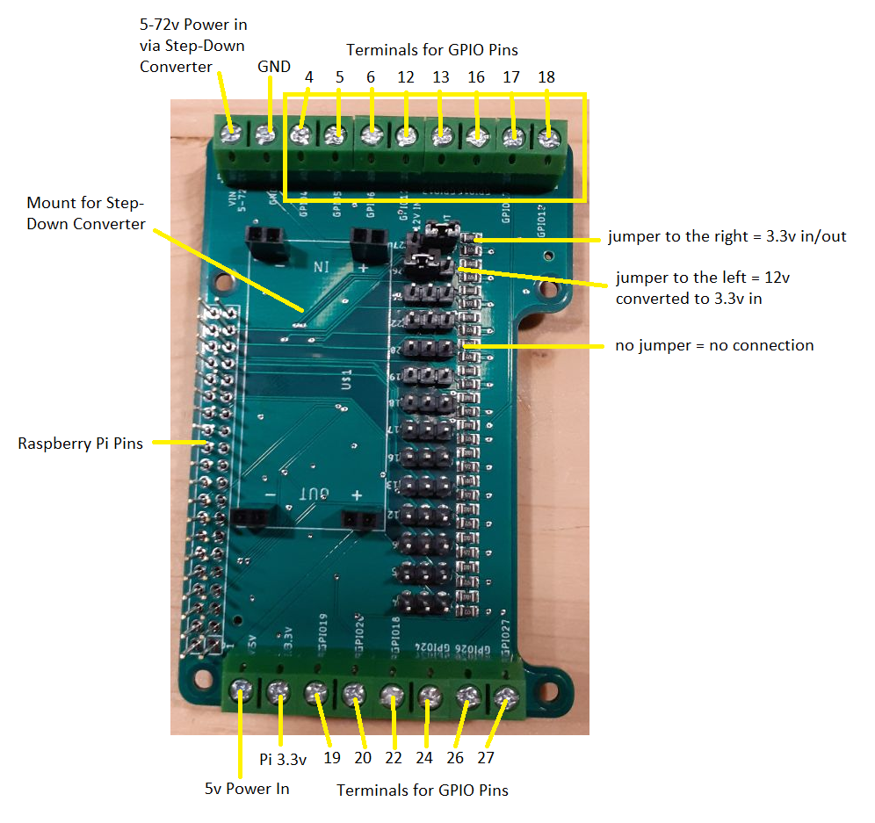

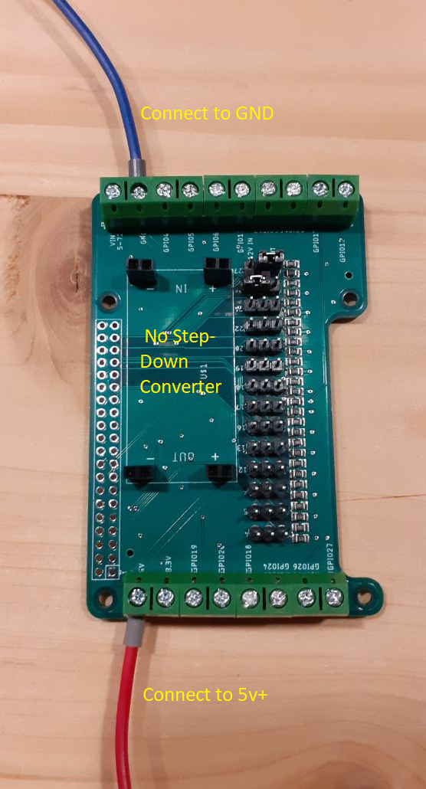Wiring for 5v Power Supply Mode

Wiring for 12v Power Supply Mode

